**ENGR 330**

**Engineering Systems Analysis and Design**

**Project II**

**Completed by:**

**Mukesh Ghimire and Emily Trolia**

**Due: Dec 1, 2018**

**Introduction**

The objective of this project was to model the vibrations caused by a particle caught up in a centrifugal pump in the impeller as shown in figure 1. The pump was assumed to be resting on vibration isolator made of spring and damper.

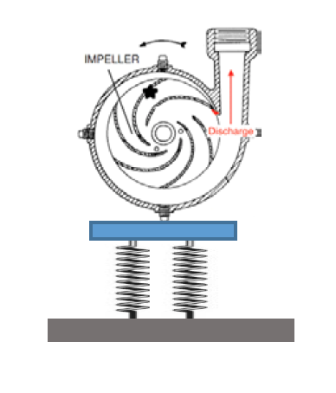

Figure 1: Centrifugal Pump

**Procedure**

The differential equation for the vibration caused by the unbalanced mass is shown below:

𝑚𝑥̈+ 𝑏𝑥̇ + 𝑘*x* = 𝜔2(𝑀𝑢n𝑒)sin(𝜔𝑡)

Simplifying the above equation, we get

$$\ddot{x}+\frac{b}{m}\dot{x}+\frac{k}{m}x= \frac{ω^{2}}{m}\left(M_{un}e\right)sin⁡(ωt)$$

In order to simplify the equation, the input was assumed to be a second derivative of:

$$U= \frac{-(M_{un}e)}{m}sin⁡(ωt)$$

Rewriting the equation in general form of the second order differential equation, we get:

$$\ddot{x}+2ζω_{n}\dot{x}+{ω_{n}}^{2}x= \frac{\left(M_{un}e\right)}{m}sin⁡(ωt)$$

Where,

$ζ$ = damping ratio = 0.01

$ω_{n}$ = undamped natural frequency = $\sqrt{\frac{k}{m}}$

k = spring constant

m = mass

Mun = unbalanced mass

e = distance from the center of rotation

Using the equation obtained above, the transfer function was generated using MATLAB and bode plots for 10 different values of k ranging from 10kN/m to 100kN/m was plotted. Each plot consisted of a peak which corresponded to the maximum displacement of the system. Using the ginput tool the peak points were picked and the corresponding displacement was measured. The plot represented displacement in the units of db, which was converted to meters using the bode plot relation. Furthermore, resonance frequency was also calculated using the relation between the natural frequency and damping ratio of the system.

$$ω_{r}=ω_{n}\sqrt{1-2ζ^{2}}$$

**Results**

The bode plot for the system is shown in figure 2. Each peak magnitude occurred close to resonant frequency. For each Bode diagram, the resonance frequency varied due to the change in the spring constant, k, for each plot. The displacement for each of the case was found out to be same. This is because the displacement of the system doesn’t change on changing the stiffness of the system. Stiffness, as seen in the graph, only changes the natural frequency of the system.

The displacement at the peak point was determined to be 0.0246 meters (or 32.1 db). Another goal of this project was to determine the rotation speed that should be avoided in each case. That is the rotation speed that resulted in the resonant frequency, which results in maximum vibration or displacement of the system, which is desirable. The rotation speed corresponding to the resonant frequency for each of the stiffness values are tabulated in table 1.

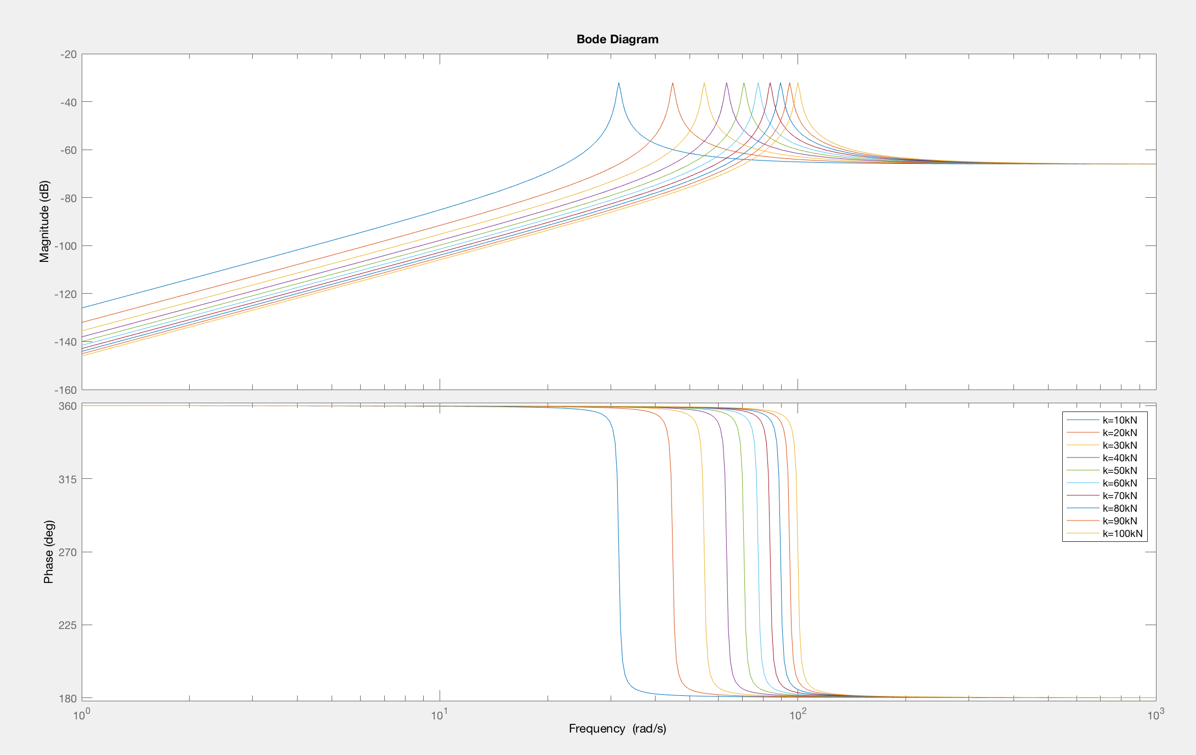

Figure 2: Bode Plot of the system

Table 1: Rotation speed to avoid for different values of k

|  |  |
| --- | --- |
| Spring Constant (kN) | Rotation Speed (rpm) |
| 10 | 301.9451 |
| 20 | 427.0148 |
| 30 | 522.9842 |
| 40 | 603.8901 |
| 50 | 675.1697 |
| 60 | 739.6114 |
| 70 | 198.8716 |
| 80 | 854.0296 |
| 90 | 905.8352 |
| 100 | 954.8342 |

**Conclusion**

Hence, for different values of spring constant (or stiffness) it was found that the displacement of the system remained unchanged. However, increasing the stiffness increased the resonant frequency of the system. The peak value represented the maximum displacement of the system that begins to occur at the resonant frequency of the system, which is usually less than the natural frequency of the system [1]. The resonant frequency should be avoided because at this frequency the system vibrates to its maximum amplitude or simply the displacement is maximum. This is not a desirable condition as it leads to an unstable system.

This project helped us understand about frequency response of a second order system when the input is sinusoidal.

**References**

[1] "Resonance Frequency is less than Natural Frequency - ProofWiki", *Proofwiki.org*, 2018. [Online]. Available: https://proofwiki.org/wiki/Resonance_Frequency_is_less_than_Natural_Frequency. [Accessed: 29- Nov- 2018]

[2] Faculty.uml.edu, 2018. [Online]. Available: http://faculty.uml.edu/pavitabile/22.457/ME22457_Chapter3_021503_MACL.pdf. [Accessed: 29- Nov- 2018]